
Te Kura o Hau Karetu
He waka eke noa: We’re all in this waka together
32 Hillside Drive, Māoribank, UPPER HUTT 5018
Phone (04) 5269-552, 027-5269-552
Email: office@tehaukaretu.school.nz

30 July 2024

Kia ora, Talofa Lava, Mālō e lelei, Kia orana, Namaste, Kumusta,

Nau mai, haere mai ki te Kura o Hau Karetu to Tangiora in Te Waipuna, Navroop in Te Pūao, and Harseerat in Te Whanganui. We are so happy to have you at our Kura.

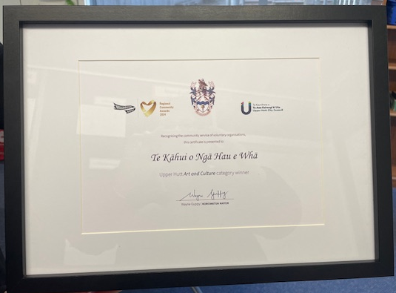
Congratulations to Te Kāhui o Ngā Hau e Whā an Upper Hutt Cluster Kapa Haka roopu who are led by our very own Whaea Paige and Whaea Carol. They won the Upper Hutt Art and Culture Award for 2024. We can’t tell you how proud we are of our Kaiako and the Tamariki who are part of this roopu/group.

Congratulations also goes to the following people in our Year 6 Hau Karetu netball team: Player of the Day Anne-Maree and Fair Play Award went to Hasandeep. We have some seriously good players in that team!

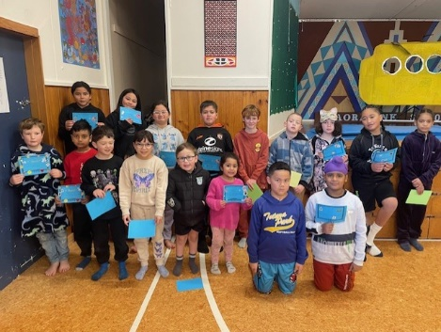
Principal’s Award winners from last week –
Congratulations to:
Jacob, Aria, Jayanch, Reid, Isla, Ayla, Winter, O’shea, Izaiah, Ryder, Tangiora, Mason L, Daniel, Trinity, Hasandeep, Tana, and Harseerat.
These tamariki have achieved things such as but not limited to: helping other people, being kind to others, working hard and achieving well in their mahi/work, and reaching goals.


MUD! Poor Whaea Roseanne. She’s inundated with children who play and then fall into the mud. We are happy for children to be on the grass if they have a change of clothes and gumboots. A reminder for people to give young children a change of clothes – especially pants. I get it – it’s loads of fun, but we have just about run out of spare pants. If your child comes up to the office wet and muddy and we have run out of clothes to put them in, we will call you to come and collect them. Thank you.


Thank you – A huge THANK YOU to Inner Wheel Upper Hutt, who knitted our younger tamariki some potae/hats and some slippers. They look so nice and cosy. Our tamariki from Te Waipuna are very grateful. I know they are busy knitting up a storm so that the rest of the school can be treated to these winter warmers!
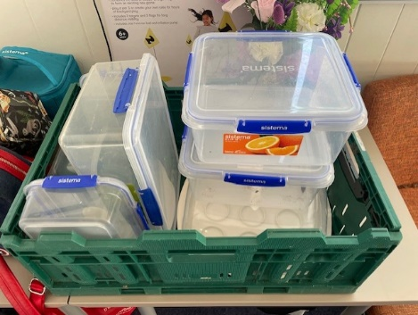
Containers:
We have lots of your containers left over from the bake sale we had in June for our fundraising bake sale at the netball. Please come and collect them. They are all Sistema containers, so good quality. If you think any of these are yours, please come and collect them from the office, or ask your child to pick it up.
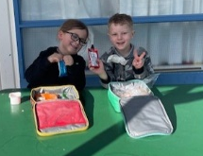
Kotahitanga – how cute are these two, having their lunch together? They were sitting in the sun, chatting away to each other and having a lovely time. Rico-John and Lyrix are both 5 years old and are in Te Waipuna class.

Goal Setting:
It’s goal setting time next week on Wednesday 7th August from 3.15-7pm, and Thursday 8th August from 3.15-5pm, here at school. Please go to the Skool Loop app and book a time to see your child’s teacher. If you don’t have the Skool Loop app, please contact Roseanne on 0275269552 to book a time. We expect every whānau/family to attend goal setting – it’s important that we are a team and present a united front for your child regarding their learning at school. Thank you.


The Hell Reading Challenge is on! Your child will have received their reading wheels today. Each time they read a book, they need to tell record the name of the book and tell their teacher so they can receive a stamp. Once the reading wheel is filled, children can take their completed wheel in to Hell Pizza where they will receive a free snack sized pizza.

For further information, go to:

https://www.nzbookawards.nz/new-zealand-book-awards-for-children-and-young-adults/the-hell-reading-challenge/

Kaupapa mō te wiki/Value for the week:
Our value for this week is Whakaute/Respect. Our goal is to work on speaking nicely to one another. Thumper from the movie Bambi says, “if you can’t say something nice, don’t say anything at all.” Those are the exact words my mother used to tell me. We need to help our children learn how to treat one another with respect – people trust someone who is respectful and they will be treated with respect themselves as a result.

Property news: - There are a lot of puddles around today. We are happy for children to play in the puddles if they have gumboots on and a change of clothes in their bags.
We have people working on trying to fix our big puddle problems, but in the meantime, if I was a kid, I would want to play in the puddles too.

Heads up:
- School Start and Finish & Attendance: Please remember that school begins at 9am and finishes at 3pm. It’s important children are at school every day and on time. However, we would rather children were at school late than not at all. Getting to school by 9am is important for children’s routines. Thank you.
- Absences: If your child is not going to be at school, please advise the office via text on 0275269552, or via the Skool Loop app. Make sure you tell us the reason they are absent.
- Entry in to and from School: Mornings - drop your child off at the front gate or the back. Our carpark can be quite full and it’s safer to drop your child off at the gate and have them walk in. You do not need to drop them to the office unless they are running late – thank you.
End of the day –
  - Front gates are closed all day from 9.30am-3.10pm. We will cross children over at the end of the day. Please use the “crossing”.
  - Back gates: These are locked during the day and will be opened again at 3pm. There will be two walking bus teachers to walk your children to the intersection of Hillside Drive, Moeraki, and Norana Roads and will be crossed over by the road patrollers.

- Breakfast Club: Runs 5 days per week from 8 – 9.30am. We are always in need of volunteers for Breakfast Club please. If you would like to volunteer for this job, please advise Roseanne or Rachel at the office. Thank you.
- Lunches in Schools: We provide lunches each day. The kai will be offered to every child. All children are expected to at least try the kai.
- Water only: We are a water only school which means children can only drink water while they are at school. We would encourage your child to bring a drink bottle of water each day.
- Assemblies: We hold our weekly celebration Assembly on Fridays at 9am. All whanau are welcome to attend.
- School Policies: Our school policies and procedures can be found at schooldocs.co.nz, username: maoribank and password waka. We would encourage you to check these out as we will ask you to have your say on their review every three years. Our current policies for review are:
  - Concerns and Complaints
  - Media
  - Performance Management
  - Protected Disclosure
  - Professional Development
  - Staff Conduct
  - Staff Leave

Ngā mihi nui
Karen Wellington,
Kaihautu/Timekeeper on the Waka

Schedule of Events Term 3, 2024
Week 2  29 July-2nd Aug | Te Mataahae whānau – please see the letter from Wainuiomata High below…
Week 3
5-9 Aug
Week 4  12-16 Aug | Tuesday - Basketball at Walter Nash Stadium – Senior students only
Week 5
19-23 Aug
Week 6  26-30 Aug | Thursday – Hui for Families of Children who are Neurodiverse – 5pm. Focus on speech language, and a letter to the government.
Week 7  2-6 Sept | Tuesday - Rippa Rugby at TMP – Matua Shea will send details soon. Thursday is postponement day.
Week 8  9-13 Sept | Friday – Wig and Onesie Day. Fundraising for Child Cancer and Wellington Free Ambulance. Wear a Onesie or wear a wig/crazy hairdo. Please bring a donation.
Week 9  16-20 Sept | Te Wiki o te Reo Māori – Māori Language Week. Watch this space, as you can be sure we’ll be doing something amazing throughout this week.
Week 10  23-27 Sept |   Book Week and Book Character Day on Friday.  Structured Literacy Information Evening for parents Monday 5.30pm.  Mrs Wellington gets her new puppy this week!

